**Practical no.-**09

**Title:** Develop a program to implement Button,Image Button and Toggle Button.

**Roll No.:**15 **Batch-** A **Date of Performance:** 08/02/2024



**activity_main.xml**

<?xml version="1.0" encoding="utf-8"?>

<AbsoluteLayout xmlns:android="http://schemas.android.com/apk/res/android" xmlns:app="http://schemas.android.com/apk/res-auto" xmlns:tools="http://schemas.android.com/tools"

android:layout_width="match_parent"

android:layout_height="match_parent"

tools:context=".MainActivity">

<Button

android:id="@+id/btn1"

android:layout_width="106dp"

android:layout_height="wrap_content"

android:layout_x="6dp"

android:layout_y="16dp"

android:text="Mickey Mouse"></Button>

<Button

android:id="@+id/btn2"

android:layout_width="106dp"

android:layout_height="wrap_content"

android:layout_x="121dp"

android:layout_y="17dp"

android:text="Chota Bheem"></Button>

<Button

android:id="@+id/btn3"

android:layout_width="106dp"

android:layout_height="wrap_content"

android:layout_x="236dp"

android:layout_y="18dp"

android:text="Tom and Jerry"></Button>

<ImageButton

android:id="@+id/img1"

android:layout_width="313dp"

android:layout_height="249dp"

android:layout_x="14dp"

android:layout_y="82dp"></ImageButton>

<ImageButton

android:id="@+id/img2"

android:layout_width="268dp"

android:layout_height="269dp"

android:layout_x="19dp"

android:layout_y="344dp"></ImageButton>

<ToggleButton

android:id="@+id/tbtn"

android:layout_width="wrap_content"

android:layout_height="wrap_content"

android:layout_x="91dp" android:layout_y="625dp">

</ToggleButton>

</AbsoluteLayout>

**MainActivity.java**

package com.example.eventhandling;

import androidx.appcompat.app.AppCompatActivity;

import android.annotation.SuppressLint;

import android.os.Bundle;

import android.view.*;

import android.widget.*;

public class MainActivity extends AppCompatActivity implements View.OnClickListener{

Button b1,b2,b3;

ImageButton im1,im2;

ToggleButton t1;

@SuppressLint("MissingInflatedId")

@Override

protected void onCreate(Bundle savedInstanceState) {

super.onCreate(savedInstanceState);

setContentView(R.layout.activity_main);

b1=(Button) findViewById(R.id.btn1);

b1.setOnClickListener(this);

b2=(Button) findViewById(R.id.btn2);

b2.setOnClickListener(this);

b3=(Button) findViewById(R.id.btn3);

b3.setOnClickListener(this);

t1=(ToggleButton) findViewById(R.id.tbtn);

t1.setOnClickListener(this);

im1=(ImageButton) findViewById(R.id.img1);

im2=(ImageButton) findViewById(R.id.img2);

}

@Override

public void onClick(View v) {

int checkbtn = v.getId();

if (checkbtn == R.id.btn1)

{

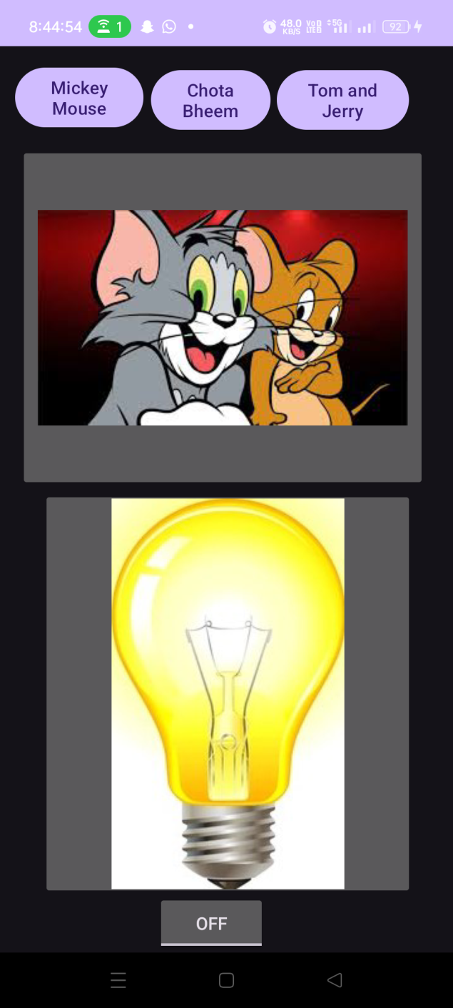 im1.setImageResource(R.drawable.mickey);

}

else if (checkbtn == R.id.btn2)

{

im1.setImageResource(R.drawable.bheem);

}

else

{

im1.setImageResource(R.drawable.tomjerry);

}

if(t1.isChecked())

{

im2.setImageResource(R.drawable.on);

}

else

{

im2.setImageResource(R.drawable.off);

}

}

}



**activity_main.xml**

<?xml version="1.0" encoding="utf-8"?>

<AbsoluteLayout xmlns:android="http://schemas.android.com/apk/res/android"

xmlns:app="http://schemas.android.com/apk/res-auto"

xmlns:tools="http://schemas.android.com/tools"

android:layout_width="match_parent"

android:layout_height="match_parent"

tools:context=".MainActivity">

<TextView

android:layout_width="wrap_content"

android:layout_height="wrap_content"

android:layout_gravity="center_horizontal"

android:layout_x="76dp"

android:layout_y="28dp"

android:text="Calculator"

android:textColor="#F48D3E"

android:textSize="50dp"

android:textStyle="bold|italic" />

<EditText

android:id="@+id/txt1"

android:layout_width="match_parent"

android:layout_height="wrap_content"

android:layout_marginLeft="20dp"

android:layout_marginTop="20dp"

android:layout_marginRight="20dp"

android:layout_x="1dp"

android:layout_y="124dp"

android:ems="10"

android:hint="First Number"

android:inputType="numberDecimal"

tools:ignore="TouchTargetSizeCheck,SpeakableTextPresentCheck" />

<EditText

android:id="@+id/txt2"

android:layout_width="match_parent"

android:layout_height="wrap_content"

android:layout_marginLeft="20dp"

android:layout_marginTop="20dp"

android:layout_marginRight="20dp"

android:layout_x="-2dp"

android:layout_y="185dp"

android:ems="10"

android:hint="Second Number"

android:inputType="numberDecimal"

tools:ignore="SpeakableTextPresentCheck,TouchTargetSizeCheck" />

<Button

android:id="@+id/btnadd"

android:layout_width="match_parent"

android:layout_height="wrap_content"

android:layout_marginLeft="20dp"

android:layout_marginTop="20dp"

android:layout_marginRight="20dp"

android:layout_x="1dp"

android:layout_y="342dp"

android:backgroundTint="#EA4444"

android:text="Add"

android:textSize="20sp" />

<Button

android:id="@+id/btnsubs"

android:layout_width="match_parent"

android:layout_height="wrap_content"

android:layout_marginLeft="20dp"

android:layout_marginTop="20dp"

android:layout_marginRight="20dp"

android:layout_x="4dp"

android:layout_y="402dp"

android:backgroundTint="#EFC547"

android:text="Subtract"

android:textSize="20sp" />

<Button

android:id="@+id/btndiv"

android:layout_width="match_parent"

android:layout_height="wrap_content"

android:layout_marginLeft="20dp"

android:layout_marginTop="20dp"

android:layout_marginRight="20dp"

android:layout_x="-1dp"

android:layout_y="531dp"

android:backgroundTint="#75DA59"

android:text="Divide"

android:textSize="20sp" />

<Button

android:id="@+id/btnmult"

android:layout_width="match_parent"

android:layout_height="wrap_content"

android:layout_marginLeft="20dp"

android:layout_marginTop="20dp"

android:layout_marginRight="20dp"

android:layout_x="4dp"

android:layout_y="466dp"

android:backgroundTint="#EF8F16"

android:text="Multiply"

android:textSize="20sp" />

<TextView

android:id="@+id/result"

android:layout_width="match_parent"

android:layout_height="37dp"

android:layout_marginLeft="20dp"

android:layout_marginTop="25dp"

android:layout_marginRight="20dp"

android:layout_x="1dp"

android:layout_y="261dp"

android:hint="Result="

android:textSize="20sp"/>

</AbsoluteLayout>

**MainActivity.java**

package com.example.calci;

import androidx.appcompat.app.AppCompatActivity;

import android.os.Bundle;

import android.view.View;

import android.widget.Button;

import android.widget.EditText;

import android.widget.TextView;

import android.widget.Toast;

import androidx.appcompat.app.AppCompatActivity;

public class MainActivity extends AppCompatActivity {

Button btnadd,btnsubs,btnmult,btndiv;

EditText txt1,txt2;

TextView result;

@Override

protected void onCreate(Bundle savedInstanceState) {

super.onCreate(savedInstanceState);

setContentView(R.layout.activity_main);

btnadd=findViewById(R.id.btnadd);

btnsubs=findViewById(R.id.btnsubs);

btndiv=findViewById(R.id.btndiv);

btnmult=findViewById(R.id.btnmult);

txt1=findViewById(R.id.txt1);

txt2=findViewById(R.id.txt2);

result=findViewById(R.id.result);

btnadd.setOnClickListener(new View.OnClickListener() {

@Override

public void onClick(View view) {

if (txt1.getText().toString().equals("")) {

Toast.makeText(MainActivity.this, "Please Enter Number", Toast.LENGTH_SHORT).show();

} else if (txt2.getText().toString().equals("")) {

Toast.makeText(MainActivity.this, "Please Enter Number", Toast.LENGTH_SHORT).show();

}

else {

float a, b, c;

a = Float.parseFloat(txt1.getText().toString());

b = Float.parseFloat(txt2.getText().toString());

c = a + b;

result.setText("The Addition Result Is " + c);

}

}

});

btnsubs.setOnClickListener(new View.OnClickListener() {

@Override

public void onClick(View view) {

if (txt1.getText().toString().equals("")) {

Toast.makeText(MainActivity.this, "Please Enter Number", Toast.LENGTH_SHORT).show();

} else if (txt2.getText().toString().equals("")) {

Toast.makeText(MainActivity.this, "Please Enter Number", Toast.LENGTH_SHORT).show();

}

else {

float a, b, c;

a = Float.parseFloat(txt1.getText().toString());

b = Float.parseFloat(txt2.getText().toString());

c = a - b;

result.setText("The Subtraction Result Is " + c);

}

}

});

btnmult.setOnClickListener(new View.OnClickListener() {

@Override

public void onClick(View view) {

if (txt1.getText().toString().equals("")) {

Toast.makeText(MainActivity.this, "Please Enter Number", Toast.LENGTH_SHORT).show();

} else if (txt2.getText().toString().equals("")) {

Toast.makeText(MainActivity.this, "Please Enter Number", Toast.LENGTH_SHORT).show();

}

else {

float a, b, c;

a = Float.parseFloat(txt1.getText().toString());

b = Float.parseFloat(txt2.getText().toString());

c = a*b;

result.setText("The Multiplication Result Is " + c);

}

}

});

btndiv.setOnClickListener(new View.OnClickListener() {

@Override

public void onClick(View view) {

if (txt1.getText().toString().equals("")) {

Toast.makeText(MainActivity.this, "Please Enter Number", Toast.LENGTH_SHORT).show();

} else if (txt2.getText().toString().equals("")) {

Toast.makeText(MainActivity.this, "Please Enter Number", Toast.LENGTH_SHORT).show();

}

else {

float a, b, c;

a = Float.parseFloat(txt1.getText().toString());

b = Float.parseFloat(txt2.getText().toString());

c = a/b;

result.setText("The Division Result Is " + c);

}

}

});

}

}

